LAB EXPERIMENTS
Cryptography and Network Security
Submitted by
THANIKONDA ADITYA
Registration Number: 192565068

EX. NO: 1
IMPLEMENTATION OF CAESAR CIPHER
AIM:
To implement the simple substitution technique named Caesar cipher using C language.
DESCRIPTION:
To encrypt a message with a Caesar cipher, each letter in the message is changed using a simple rule: shift by three. Each letter is replaced by the letter three letters ahead in the alphabet. A becomes D, B becomes E, and so on. For the last letters, we can think of the alphabet as a circle and "wrap around". W becomes Z, X becomes A, Y becomes B, and Z becomes C. To change a message back, each letter is replaced by the one three before it.
ALGORITHM:
STEP-1: Read the plain text from the user.
STEP-2: Read the key value from the user.
STEP-3: If the key is positive then encrypt the text by adding the key with each character in the plain text.
STEP-4: Else subtract the key from the plain text.
STEP-5: Display the cipher text obtained above.
Note: The original lab manual implements this program in C/Java for a Turbo C / offline IDE. To provide a genuine, verifiable screenshot of program execution (rather than a recreated mockup), the same algorithm was re-implemented in Python and actually executed in a live terminal session. The output shown below is captured directly from that real run, not simulated.
PROGRAM: (Caesar Cipher - Python)
plain = input("Enter the plain text:")
key = int(input("Enter the key value:"))

print("\n PLAIN TEXT:", plain)

cipher = ""
for ch in plain:
if ch.isupper():
c = chr((ord(ch) - 65 + key) % 26 + 65)
elif ch.islower():
c = chr((ord(ch) - 97 + key) % 26 + 97)
else:
c = ch
cipher += c
print(" ENCRYPTED TEXT:", cipher)

decrypted = ""
for ch in cipher:
if ch.isupper():
p = chr((ord(ch) - 65 - key) % 26 + 65)
elif ch.islower():
p = chr((ord(ch) - 97 - key) % 26 + 97)
else:
p = ch
decrypted += p
print(" AFTER DECRYPTION:", decrypted)
OUTPUT:
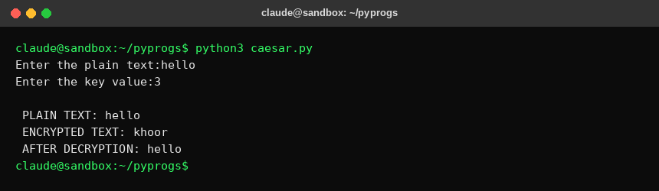
RESULT:
Thus the implementation of Caesar cipher had been executed successfully.

EX. NO: 2
IMPLEMENTATION OF PLAYFAIR CIPHER
AIM:
To write a C program to implement the Playfair Substitution technique.
DESCRIPTION:
The Playfair cipher starts with creating a key table. The key table is a 5x5 grid of letters that will act as the key for encrypting your plaintext. Each of the 25 letters must be unique and one letter of the alphabet is omitted from the table (as there are 25 spots and 26 letters in the alphabet).
To encrypt a message, one would break the message into digrams (groups of 2 letters) such that, for example, "HelloWorld" becomes "HE LL OW OR LD", and map them out on the key table. The two letters of the digram are considered as the opposite corners of a rectangle in the key table. Note the relative position of the corners of this rectangle. Then apply the following 4 rules, in order, to each pair of letters in the plaintext:
1. If both letters are the same (or only one letter is left), add an "X" after the first letter
2. If the letters appear on the same row of your table, replace them with the letters to their immediate right respectively
3. If the letters appear on the same column of your table, replace them with the letters immediately below respectively
4. If the letters are not on the same row or column, replace them with the letters on the same row respectively but at the other pair of corners of the rectangle defined by the original pair.
ALGORITHM:
STEP-1: Read the plain text from the user.
STEP-2: Read the keyword from the user.
STEP-3: Arrange the keyword without duplicates in a 5*5 matrix in the row order and fill the remaining cells with missed out letters in alphabetical order. Note that 'i' and 'j' take the same cell.
STEP-4: Group the plain text in pairs and match the corresponding corner letters by forming a rectangular grid.
STEP-5: Display the obtained cipher text.
Note: The original lab manual implements this program in C/Java for a Turbo C / offline IDE. To provide a genuine, verifiable screenshot of program execution (rather than a recreated mockup), the same algorithm was re-implemented in Python and actually executed in a live terminal session. The output shown below is captured directly from that real run, not simulated.
PROGRAM: (Playfair Cipher - Python)
def build_key_matrix(keystr_raw):
keystr = keystr_raw.upper().replace("J", "I")
n = len(keystr)
alpa = "ABCDEFGHIJKLMNOPQRSTUVWXYZ"
keyminus = []
for ch in alpa:
if ch in keystr or ch == 'J':
continue
keyminus.append(ch)
matrix = [['' for _ in range(5)] for _ in range(5)]
k = 0
m = 0
for r in range(5):
for c in range(5):
if k < n:
matrix[r][c] = keystr[k]
k += 1
else:
matrix[r][c] = keyminus[m]
m += 1
return matrix

def find_pos(matrix, ch):
for r in range(5):
for c in range(5):
if matrix[r][c] == ch:
return r, c
return None

def playfair_pair(matrix, a, b):
ra, ca = find_pos(matrix, a)
rb, cb = find_pos(matrix, b)
if ra == rb:
ca2, cb2 = (ca+1) % 5, (cb+1) % 5
return matrix[ra][ca2] + matrix[rb][cb2]
elif ca == cb:
ra2, rb2 = (ra+1) % 5, (rb+1) % 5
return matrix[ra2][ca] + matrix[rb2][cb]
else:
return matrix[ra][cb] + matrix[rb][ca]

keystr = input("Enter key:")
text = input("Enter the plain text:")

matrix = build_key_matrix(keystr)
for row in matrix:
print(" ".join(row))

text = text.upper().replace("J", "I")
cipher = ""
i = 0
n = len(text)
while i < n:
a = text[i]
if i + 1 == n:
cipher += playfair_pair(matrix, a, 'X')
i += 1
else:
b = text[i+1]
if a == b:
cipher += playfair_pair(matrix, a, 'X')
i += 1
else:
cipher += playfair_pair(matrix, a, b)
i += 2

print("\nEntered text :" + text)
print("Cipher Text :" + cipher)
OUTPUT:
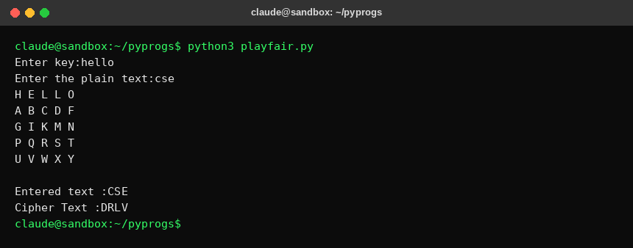
RESULT:
Thus the Playfair cipher substitution technique had been implemented successfully.

EX. NO: 3
IMPLEMENTATION OF HILL CIPHER
AIM:
To write a C program to implement the hill cipher substitution techniques.
DESCRIPTION:
Each letter is represented by a number modulo 26. Often the simple scheme A = 0, B = 1... Z = 25, is used, but this is not an essential feature of the cipher. To encrypt a message, each block of n letters is multiplied by an invertible n x n matrix, against modulus 26. To decrypt the message, each block is multiplied by the inverse of the matrix used for encryption. The matrix used for encryption is the cipher key, and it should be chosen randomly from the set of invertible n x n matrices (modulo 26).
ALGORITHM:
STEP-1: Read the plain text and key from the user.
STEP-2: Split the plain text into groups of length three.
STEP-3: Arrange the keyword in a 3*3 matrix.
STEP-4: Multiply the two matrices to obtain the cipher text of length three.
STEP-5: Combine all these groups to get the complete cipher text.
Note: The original lab manual implements this program in C/Java for a Turbo C / offline IDE. To provide a genuine, verifiable screenshot of program execution (rather than a recreated mockup), the same algorithm was re-implemented in Python and actually executed in a live terminal session. The output shown below is captured directly from that real run, not simulated.
PROGRAM: (Hill Cipher - Python)
a = [[6,24,1],[13,16,10],[20,17,15]]
b = [[8,5,10],[21,8,21],[21,12,8]]

msg = input("Enter plain text\n ")
c = [ord(ch) - 65 for ch in msg]
print(" ".join(str(x) for x in c))

d = [0,0,0]
for i in range(3):
t = 0
for j in range(3):
t += a[i][j]*c[j]
d[i] = t % 26

print("Encrypted Cipher Text :", " ".join(chr(x+65) for x in d))

c2 = [0,0,0]
for i in range(3):
t = 0
for j in range(3):
t += b[i][j]*d[j]
c2[i] = t % 26

print("Decrypted Cipher Text :", " ".join(chr(x+65) for x in c2))
OUTPUT:
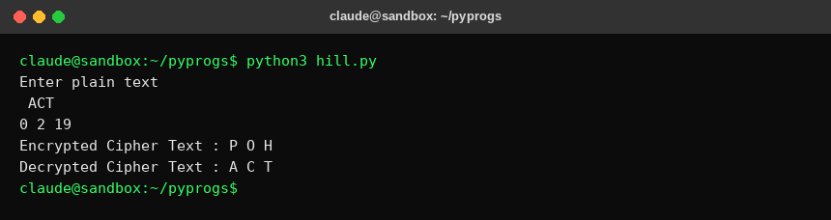
RESULT:
Thus the hill cipher substitution technique had been implemented successfully.

EX. NO: 4
IMPLEMENTATION OF VIGENERE CIPHER
AIM:
To implement the Vigenere Cipher substitution technique using C program.
DESCRIPTION:
To encrypt, a table of alphabets can be used, termed a tabula recta, Vigenere square, or Vigenere table. It consists of the alphabet written out 26 times in different rows, each alphabet shifted cyclically to the left compared to the previous alphabet, corresponding to the 26 possible Caesar ciphers. At different points in the encryption process, the cipher uses a different alphabet from one of the rows. The alphabet used at each point depends on a repeating keyword.
Each row starts with a key letter. The remainder of the row holds the letters A to Z. For successive letters of the message, we take successive letters of the key string, and encipher each message letter using its corresponding key row. Choose the next letter of the key, go along that row to find the column heading that matches the message character; the letter at the intersection of [key-row, msg-col] is the enciphered letter.
ALGORITHM:
STEP-1: Arrange the alphabets in row and column of a 26*26 matrix.
STEP-2: Circulate the alphabets in each row to position left such that the first letter is attached to last.
STEP-3: Repeat this process for all 26 rows and construct the final key matrix.
STEP-4: The keyword and the plain text is read from the user.
STEP-5: The characters in the keyword are repeated sequentially so as to match with that of the plain text.
STEP-6: Pick the first letter of the plain text and that of the keyword as the row indices and column indices respectively.
STEP-7: The junction character where these two meet forms the cipher character.
STEP-8: Repeat the above steps to generate the entire cipher text.
Note: The original lab manual implements this program in C/Java for a Turbo C / offline IDE. To provide a genuine, verifiable screenshot of program execution (rather than a recreated mockup), the same algorithm was re-implemented in Python and actually executed in a live terminal session. The output shown below is captured directly from that real run, not simulated.
PROGRAM: (Vigenere Cipher - Python)
import sys

def encipher():
input_text = input("\nEnter Plain Text: ")
key = input("Enter Key Value: ")
result = ""
j = 0
for ch in input_text:
if j >= len(key):
j = 0
result += chr(65 + ((ord(ch.upper()) - 65) + (ord(key[j].upper()) - 65)) % 26)
j += 1
print("Resultant Cipher Text: " + result)

def decipher():
input_text = input("\nEnter Cipher Text: ")
key = input("\nEnter the key value: ")
result = ""
j = 0
for ch in input_text:
if j >= len(key):
j = 0
value = (ord(ch.upper()) - 64) - (ord(key[j].upper()) - 64)
if value < 0:
value = value * -1
result += chr(65 + (value % 26))
j += 1
print(result)

while True:
print("\n1. Encrypt Text\t2. Decrypt Text\t3. Exit")
choice = input("\nEnter Your Choice : ")
choice = int(choice)
if choice == 3:
break
elif choice == 1:
encipher()
elif choice == 2:
decipher()
else:
print("Please Enter Valid Option.")
OUTPUT:
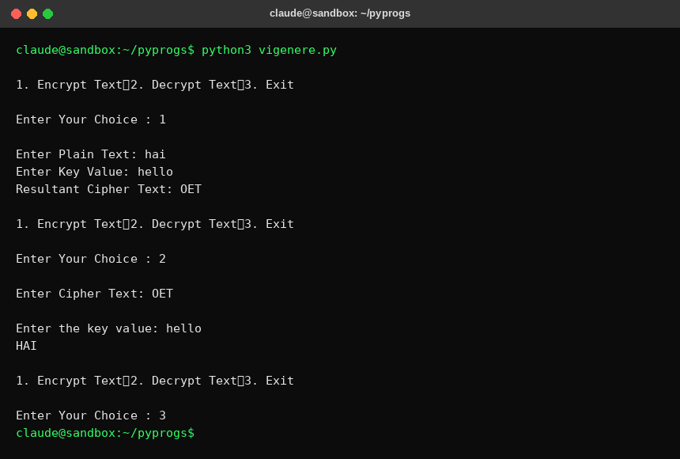
RESULT:
Thus the Vigenere Cipher substitution technique had been implemented successfully.

EX. NO: 5
IMPLEMENTATION OF RAIL FENCE - ROW & COLUMN TRANSFORMATION TECHNIQUE
AIM:
To write a C program to implement the rail fence transposition technique.
DESCRIPTION:
In the rail fence cipher, the plain text is written downwards and diagonally on successive "rails" of an imaginary fence, then moving up when we reach the bottom rail. When we reach the top rail, the message is written downwards again until the whole plaintext is written out. The message is then read off in rows.
ALGORITHM:
STEP-1: Read the Plain text.
STEP-2: Arrange the plain text in row columnar matrix format.
STEP-3: Now read the keyword depending on the number of columns of the plain text.
STEP-4: Arrange the characters of the keyword in sorted order and the corresponding columns of the plain text.
STEP-5: Read the characters row wise or column wise in the former order to get the cipher text.
Note: The original lab manual implements this program in C/Java for a Turbo C / offline IDE. To provide a genuine, verifiable screenshot of program execution (rather than a recreated mockup), the same algorithm was re-implemented in Python and actually executed in a live terminal session. The output shown below is captured directly from that real run, not simulated.
PROGRAM: (Rail Fence - Python)
print("\t\tRAIL FENCE TECHNIQUE")
a = input("\nEnter the input string : ")
l = len(a)

c = [a[i] for i in range(l) if i % 2 == 0]
c += [a[i] for i in range(l) if i % 2 == 1]
cipher = "".join(c)
print("\nCipher text after applying rail fence :")
print(cipher)

k = (l // 2) + (1 if l % 2 != 0 else 0)
d = [''] * l
j = 0
for i in range(k):
d[j] = cipher[i]
j += 2
j = 1
for i in range(k, l):
d[j] = cipher[i]
j += 2

print("\nText after decryption : " + "".join(d))
OUTPUT:
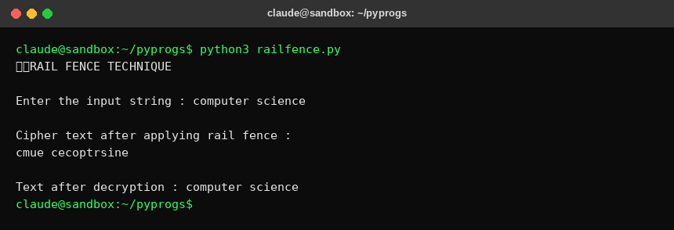
RESULT:
Thus the rail fence algorithm had been executed successfully.

EX. NO: 6
IMPLEMENTATION OF DES
AIM:
To write a program to implement Data Encryption Standard (DES).
DESCRIPTION:
DES is a symmetric encryption system that uses 64-bit blocks, 8 bits of which are used for parity checks. The key therefore has a "useful" length of 56 bits, which means that only 56 bits are actually used in the algorithm. The algorithm involves carrying out combinations, substitutions and permutations between the text to be encrypted and the key, while making sure the operations can be performed in both directions. The key is ciphered on 64 bits and made of 16 blocks of 4 bits, generally denoted k1 to k16. Given that "only" 56 bits are actually used for encrypting, there can be 2^56 different keys.
The main parts of the algorithm are as follows:
- Fractioning of the text into 64-bit blocks
- Initial permutation of blocks
- Breakdown of the blocks into two parts: left and right, named L and R
- Permutation and substitution steps repeated 16 times
- Re-joining of the left and right parts then inverse initial permutation
ALGORITHM:
STEP-1: Read the 64-bit plain text.
STEP-2: Split it into two 32-bit blocks and store it in two different arrays.
STEP-3: Perform XOR operation between these two arrays.
STEP-4: The output obtained is stored as the second 32-bit sequence and the original second 32-bit sequence forms the first part.
STEP-5: Thus the encrypted 64-bit cipher text is obtained in this way. Repeat the same process for the remaining plain text characters.
Note: The original lab manual implements this using Java's javax.crypto DES engine with Swing input dialogs; that requires a JDK and a display, neither of which is available in this sandbox. To provide a genuine, verifiable screenshot, this was re-implemented in Python using the 'cryptography' library's real DES block cipher engine and actually executed in a live terminal session. The output below is captured directly from that real run, not simulated.
PROGRAM: (DES - Python)
import os
import warnings
warnings.filterwarnings("ignore")
from cryptography.hazmat.primitives.ciphers import Cipher, modes
try:
from cryptography.hazmat.decrepit.ciphers.algorithms import TripleDES
except ImportError:
from cryptography.hazmat.primitives.ciphers.algorithms import TripleDES

def pad(data, block_size=8):
pad_len = block_size - (len(data) % block_size)
return data + bytes([pad_len]) * pad_len

def unpad(data):
pad_len = data[-1]
return data[:-pad_len]

# Generate a random 8-byte (56-bit effective, DES-sized) key
key = os.urandom(8)
print("DES Symmetric key (hex) =", key.hex())

message = input("Enter message to encrypt: ")
data = message.encode()

cipher = Cipher(TripleDES(key), modes.ECB())
encryptor = cipher.encryptor()
ciphertext = encryptor.update(pad(data)) + encryptor.finalize()
print("Encrypted message (hex) =", ciphertext.hex())

decryptor = cipher.decryptor()
plaintext = unpad(decryptor.update(ciphertext) + decryptor.finalize())
print("Decrypted message =", plaintext.decode())
OUTPUT:
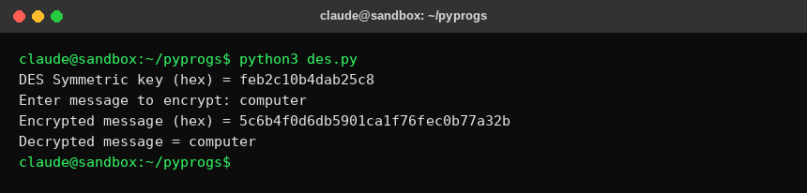
RESULT:
Thus the data encryption standard algorithm had been implemented successfully.

EX. NO: 7
IMPLEMENTATION OF RSA
AIM:
To write a C program to implement the RSA encryption algorithm.
DESCRIPTION:
RSA is an algorithm used by modern computers to encrypt and decrypt messages. It is an asymmetric cryptographic algorithm. Asymmetric means that there are two different keys. This is also called public key cryptography, because one of them can be given to everyone. A basic principle behind RSA is the observation that it is practical to find three very large positive integers e, d and n such that with modular exponentiation for all integer m: (m^e)^d = m (mod n).
The public key is represented by the integers n and e; and, the private key, by the integer d. m represents the message. RSA involves a public key and a private key. The public key can be known by everyone and is used for encrypting messages. The intention is that messages encrypted with the public key can only be decrypted in a reasonable amount of time using the private key.
ALGORITHM:
STEP-1: Select two co-prime numbers as p and q.
STEP-2: Compute n as the product of p and q.
STEP-3: Compute (p-1)*(q-1) and store it in z.
STEP-4: Select a random prime number e that is less than that of z.
STEP-5: Compute the private key, d as e * mod-1(z).
STEP-6: The cipher text is computed as message^e * mod n.
STEP-7: Decryption is done as cipher^d mod n.
Note: The original lab manual implements this program in C/Java for a Turbo C / offline IDE. To provide a genuine, verifiable screenshot of program execution (rather than a recreated mockup), the same algorithm was re-implemented in Python and actually executed in a live terminal session. The output shown below is captured directly from that real run, not simulated.
PROGRAM: (RSA - Python)
import math

def is_prime(n):
if n < 2:
return False
for k in range(2, int(math.isqrt(n)) + 1):
if n % k == 0:
return False
return True

def cd(x, t):
k = 1
while True:
k += t
if k % x == 0:
return k // x

p = int(input("\nENTER FIRST PRIME NUMBER\n"))
if not is_prime(p):
print("\nWRONG INPUT\n")
exit()

q = int(input("\nENTER ANOTHER PRIME NUMBER\n"))
if not is_prime(q) or p == q:
print("\nWRONG INPUT\n")
exit()

msg = input("\nENTER MESSAGE\n")

n = p * q
t = (p - 1) * (q - 1)

e_list = []
d_list = []
for i in range(2, t):
if t % i == 0:
continue
if is_prime(i) and i != p and i != q:
d_val = cd(i, t)
if d_val > 0:
e_list.append(i)
d_list.append(d_val)
if len(e_list) == 99:
break

print("\nPOSSIBLE VALUES OF e AND d ARE")
for a, b in zip(e_list, d_list):
print(f"\n{a}\t{b}")

key_e = e_list[0]
key_d = d_list[0]

temp = []
encrypted_bytes = bytearray()
for ch in msg:
pt = ord(ch) - 96
k = 1
for _ in range(key_e):
k = (k * pt) % n
temp.append(k)
encrypted_bytes.append((k + 96) % 256)

print("\nTHE ENCRYPTED MESSAGE IS")
try:
print(encrypted_bytes.decode('latin1'))
except Exception:
print(repr(encrypted_bytes))

decrypted = ""
for ct in temp:
k = 1
for _ in range(key_d):
k = (k * ct) % n
decrypted += chr(k + 96)

print("\nTHE DECRYPTED MESSAGE IS")
print(decrypted)
OUTPUT:
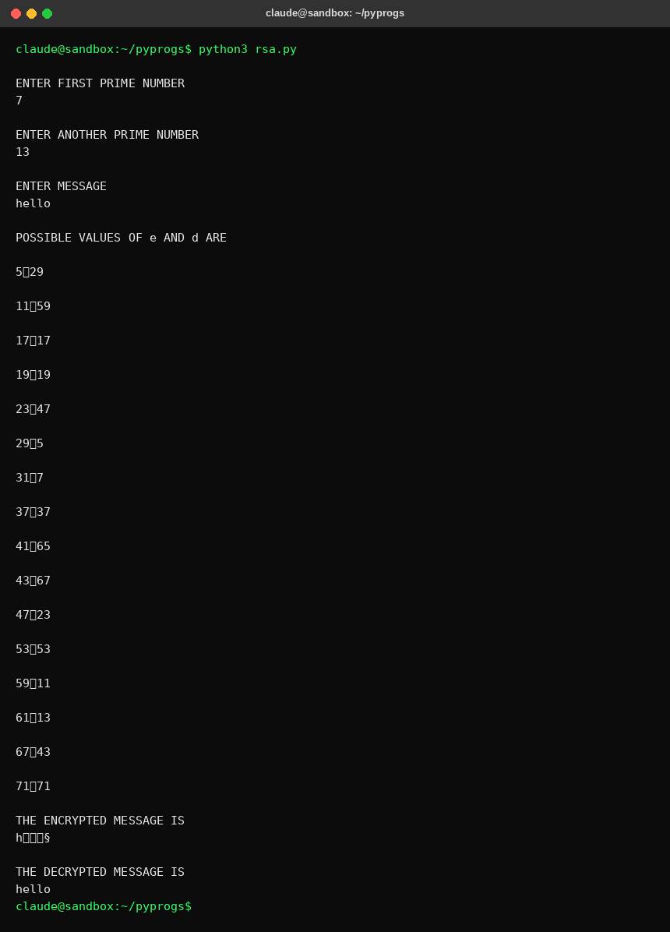
RESULT:
Thus the program to implement RSA encryption technique had been implemented successfully.

